Introduction

To learn more about the beautiful county of Shropshire, I use my photographs to investigate the history and explore the landscape.

My photographs are presented via a web site, which is organised into the following areas:

* History
* Landscape
* Castles
* Churches
* People
* Folklore
* Gardens
* Miscellaneous

All assets relating to the Shropshire project are held on the Google Drive in the folder:

C:\Users\David\Documents\Google Drive\3. Shropshire

The web site is hosted on GitHub - username is dmfbsh - web site is:

<https://dmfbsh.github.io/>

Photo Selection

All my photographs are catalogued in ACDSee Photo Studio Standard.

A hierarchy of Categories is set up:

* Shropshire
  + History
  + Landscape
  + Other

1. Select the image and assign to the appropriate Category under the Shropshire top level Category.

1. Create a folder for the Place in the project folder (C:\Users\David\Documents\Google Drive\3. Shropshire\Photography).

1. Use the Shropshire Photography script (from within ACDSee Photo Studio Standard) to assign the image to the Place.

Shropshire Photography 
Original 
Acton Burnell - Castle 
Jumoswestry 

Photo Development

The selected 'raw' photograph must be processed to create a JPG file for use in the project.

1. From ACDSee Photo Studio Standard open the selected photograph using DxO PhotoLab.

1. Develop the photograph using DxO PhotoLab:
   1. Apply a Preset.
   2. Apply any other edits as needed, e.g. ViewPoint.
   3. Export as a JPEG file - there is a preset defined for this to export the file as JPG (95%) to the folder: C:\Users\David\Documents\Google Drive\3. Shropshire\Photography

Export to disk Options 
Shropshire Photography 
JPEG (qt.ulity 95) - Fun size 
Destination: C.A Whotography 
Nikon Image Space 
JPEG - 2400 pixels 
iDevices - 2018 
JPEG - 2048 pixels 
L:VMy 
iDevices - 2019 
- 2048 pixels 
L: iMy 
Add new option 
Shropshire Photography 
Process as 
Quality 
Destination 
Path 
suffix 
Resolution 
JPEG 
Custom folder 
- settings - 
Oxo 
300 
Allow image resampling 
ICC profile Original 
Remcn.'e EXIF data 
Export 
95 
Cancel 

1. Copy the developed photograph to the folder for the Place.

1. Record the PhotoLab preset used and any other edits in the Shropshire Photography project status notes:

Shropshire Photography 
Acton Burnell - Castle 
Category: 
Original 
D XO Photo I _ab Pre set: 
OXO Photol_ab Notes ' 
Affinity Photo Notes : 
Notes 
OXO Silver Efex 
Miscellaneous Notes: 
Subject Notes • 
Notes for Web: 
C O mpl 
Notepad: 
aurnell 1 1 tm2018-06-11 
1 - Oxo standard 
Straighten the building using Viewpoint 
arious control points used to improve the image 
017 Full Spectrum 
Has Notes File 

1. Edit the photograph in Affinity Photo as needed and record the edits in the Shropshire Photography project status notes.

1. Edit the photograph in Perfectly Clear as needed and record the edits in the Shropshire Photography project status notes.

Note that Perfectly Clear is not compatible with Affinity Photo.

1. Convert to Black and White using DxO Silver Efex Pro and record the preset used in the Shropshire Photography project status notes.

This is typically done by accessing DxO Silver Efex Pro from Affinity Photo as a plugin and exporting the photograph from Affinity Photo.

Maps

Shropshire

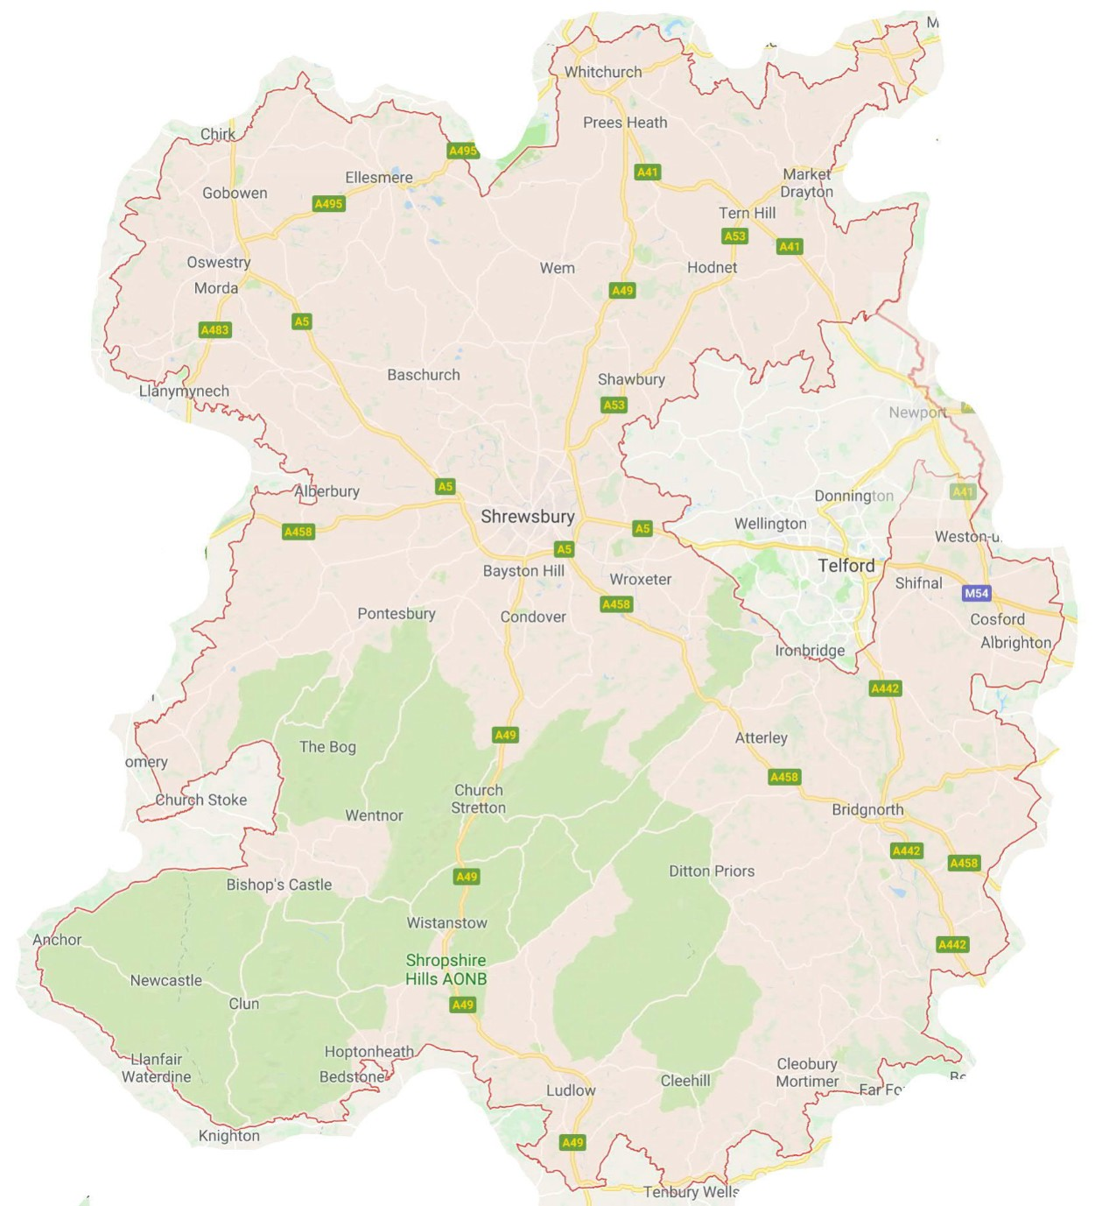

F - Morville Hall

Open

May 10 & 11

June 14 & 15

July 12 & 13

Sept 13 & 14

G - Daniels Mill

<https://www.danielsmill.co.uk>

DANIELS MILL IS SITUATED NEAR THE SEVERN VALLEY RAILWAY HALF A MILE FROM THE JUNCTION OF THE HIGHLEY (B4555) AND CLEOBURY MORTIMER (B4363) ROADS OUT OF BRIDGNORTH.

Daniels Mill,

Eardington,

Bridgnorth,

Shropshire,

WV16 5JL

Opening Times

April to end of October

Open Thursday – Sunday 11am to 4pm

Open Bank Holiday Mondays.

H - St Mildburh / Mildburga / Mildburgh Church, Beckbury

<https://britishlistedbuildings.co.uk/101367602-church-of-st-milburga-beckbury>

TF11 9DG

I - Pitchford Hall

Tour

30/03/19 Sat

10/04/19 Wed

27/04/19 Sat

11/05/19 Sat

29/05/19 Wed

05/06/19 Wed

19/06/19 Wed

22/06/19 Sat

SY5 7DN

L - Stokesay Court

Tour

09/05/19 Thu

06/06/19 Thu

SY7 9BD

M - Brynkinalt Hall

23/05

04/06

06/06

18/06

25/06

02/09

10/09

LL14 5NS

N - Melverley Church

SY10 8PJ

O - Woolstaston Church

SY6 6NN

<http://steeplewood.org.uk/index.html>

Q - Longnor Church

SY5 7PX

<http://steeplewood.org.uk/index.html>

Ashes Hollow

Light spout hollow

Rotunda - Ironbridge - view of the bridge

**Visited**

A - Hope Bagot Church

One of the oldest yew trees in Shropshire is to be found in the churchyard at Hope Bagot, near Ludlow. It is believed to be more than 1,600 years old, and its hollow trunk contains offerings left by those who believe this is a sacred site. The yew stands directly above a holy well, whose water is said to be good for sore eyes.

The church dates from Norman times and is well worth a visit. According to the guidebook, one of the two millstones used as corner stones for the tower may have been declared deodand - given to God - following the death of a local miller in an accident in the 13th century. Another reminder of mortality can be found inside the church, where a memorial refers to death as ‘the King of Terrors’.

But gloomy thoughts were far away yesterday when we visited this beautiful place beneath the slopes of Titterstone Clee. It was a bitterly cold day, but the bright sunshine and sound of birdsong made it feel as if spring is only just around the corner.

Hope Bagot, Ludlow, SY8 3AF

B - St Laurence Church - Ludlow

Climb tower

C - Upton Cressett - Church

<https://www.visitchurches.org.uk/visit/church-listing/st-michaels-upton-cressett.html>

Upton Cressett, Bridgnorth, Shropshire, WV16 6UH

D - Flounders Folly

<http://www.floundersfolly.org.uk>

Month        Dates        Times

January 2019        27th        11am – 3pm

Feb 2019        24th        11am – 3pm

March 2019        31st        11am – 4pm

April 2019        19th (Good Friday)        11am – 4pm

22nd (Easter Monday)        11am – 4pm

        28th         11am – 4pm

May 2019        6th (Bank Holiday)        11am – 4pm

26th        11am – 4pm

        27th (Bank Holiday)        11am – 4pm

June 2019        30th         11am – 4pm

July 2019        28th        11am – 4pm

Aug 2019        25th        11am – 4pm

26th (Bank Holiday)        11am – 4pm

Sept 2019        21st (Heritage open day)        11am – 2pm

29th         11am – 4pm

Oct 2019        27th        11am – 3pm

Nov 2019        24th        11am – 3pm

E - Shipton Church

TF13 6JZ

<http://www.discovershropshirechurches.co.uk/south-east-shropshire/shipton/>

P - Smethcott Church

SY6 6NX

<http://steeplewood.org.uk/index.html>

K - Offa’s Dyke Visitor Centre

Devil’s Pulpit

<https://offasdyke.org.uk/offas-dyke-association/offas-dyke-centre/>

LD7 1EN

J - Old Oswestry Hill Fort

About half mile from centre

Web Site